Name : TAHSEEN ALAM  
DAY 2 INTERNSHIP

EMAIL PHISHING SPOOFING

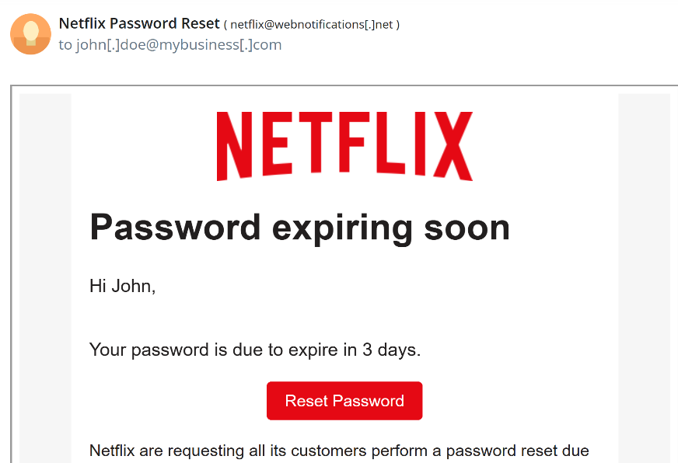

**Spoofing Indicators in This Email**

**1. Sender Address Mismatch**

* **Displayed Name:** Netflix Password Reset
* **Actual Email:** [netflix@webnotifications[.]net](mailto:netflix@webnotifications[.]net)

This domain is **not owned by Netflix**. Official Netflix emails usually come from:

@netflix.com

@mailer.netflix.com

* **Generic Greeting**

It says: *"Hi John"*

This might seem personalized, but often attackers guess common names or use public data.

Real Netflix emails usually include **full names and personalized details** from your account.

* **Language/Grammar Issues**

Sentence: *"Netflix are requesting..."*

This is grammatically incorrect. It should be “Netflix is requesting…”

* **SUMMARY**

| **Sign** | **Description** |
| --- | --- |
|  |  |

|  |  |
| --- | --- |
| Fake sender address | @webnotifications[.]net instead of @netflix.com |

|  |  |
| --- | --- |
| Urgent language | “Password expiring soon” |

|  |  |
| --- | --- |
| Suspicious link | Likely redirects to a phishing site |

|  |  |
| --- | --- |
| Poor grammar | “Netflix are…” |

|  |  |
| --- | --- |
|  |  |